Testimony
A Pamphlet from Pax Christi Texas

Anticipating January 23 and 30, 2022
Communications with the editor should be sent to j6anthonyblasi@yahoo.com. Pax Christi International was founded in 1945 with the encouragement of Bishop Pierre Marie Théas of Montauban, France, by Marthe Dortel Claudot, as a Christian lay organization dedicated to preventing a repetition of the savagery of the twentieth century’s world wars.

Editorial
After the calendar, the Sunday Liturgical Reading reflections are based on the readings for the Third and Fourth Weeks of Ordinary Time. The readings for two Sundays are reviewd because the editor has a scheduled hospitalization. Tom Keene’s poem is Prayer. For more of Tom’s poems, see http://www.tomkeeneandthemuse.com/index.php. After the poem is a news item from Pax Christi International on a United Nations-sponsored meeting on killer robots as weapons of war.

Calendar
Times are given for the Central Time Zone.

January 23, Third Sunday in Ordinary Time
First Reading (Nehemiah 8:2-4a, 5-6, 8-10)
The books of Ezra and Nehemiah, as we have them, were a single book, evidently composed as an appendix to the books of Chronicles. Passages in the Ezra section and the Nehemiah section were displaced into one another; commentators devote much effort to identifying the displaced passages and establishing their original order. That need not detain us here.
The Lectionary presents us with a section in which Ezra, in his first term at governing Judah as a province in the Persian Empire after the Babylonian captivity, reads his strict version of the religious Law and the local people weep. Ezra and his assistants, who are named in verses that the Lectionary deletes, try to convince them to be happy. The next chapter in Nehemiah says the people went away happy. Most commentators agree that the Ezra narrative of the reading of the Law had been displaced from the Ezra section of the book and ended up in the Nehemiah section. Nehemiah, it turns out, had a milder version of the law, and the public reading of that version is what made the people happy.
Ezra had led a contingent of returnees from Babylon who had a nationalistic agenda. They ended up in a conflict with the local people, who had established peaceful relations with their non-Hebrew neighbors. Nehemiah, in his term in office, wanted to re-establish those friendly relations. This sounds so familiar, centuries, millennia, later! Should there be legal barriers around the faithful, or openings and outreach?

Second Reading (1 Corinthians 12:12-30)
“If the foot were to say, ‘Because I am not a hand, I am not part of the body,’ it is not on that account not part of the body; and if the ear were to say, ‘Because I am not an eye, I am not part of the body,’ it is not on that account not part of the body.” This continues Paul’s discourse on the variety of assignments in the church, the reading of which began last Sunday. In the development of his argument, a fundamental distinction is made between what someone claims and what is true.
We have been witnessing in current affairs extravagant departures from reality in political discourse. Of course, I have in mind the debate over “the wall,” but there are many other cases as well. Rhetorically we hear about an invasion of thousands of terrorists from the Middle East (There’s a stereotype, for sure!) sneaking across the U.S. border with Mexico; in reality there are refugee families trying to escape gang terrorism in Central America. Rhetorically we hear about a “humanitarian disaster” that requires a wall; in reality the refugee question has become a “disaster” because a dishonorable government refuses to live up to treaties about the treatment of refugees. Also in reality, a wall would neither feed, clothe, nor house anyone.
Walls do not provide security half as well as justice does. The Berlin Wall did not protect the Communist regime of the former East Germany from the quest for freedom. The big walls between Israeli occupied lands and Palestinian communities will be gone before the century is over because the injustices they harden will in the long run undo the false legitimacy they are intended to shield.
What are such walls really for? The reading actually alludes to an answer: “…one body, whether Jews or Greeks, whether slave or free….” A wall is essentially a symbol of a division—a division that is ultimately a falsehood.

Third Reading (Luke 1.1-4, 4.14-21)
It is tempting to skip over Luke’s introduction to his gospel, but we can learn some things about early Christianity from it. The practice was to catechize new Christians with the sayings of Jesus: “…the sayings by which you were catechized.” These would include such passages as the Beatitudes, the Lord’s Prayer, and the parables. Luke says he was adding the narrative of the deeds of Jesus, which he was putting in a serviceable order:

Whereas many attempted to reorder the narration of the doings that have been confirmed among us, as eye-witnessed from the outset and those who became ministers of the word handed down to us, I too, having traced everything accurately from the beginning, thought to write it in an order for you, O excellent Theophilus, so that you may learn to have confidence in the sayings by which you were catechized.

The focus of the good news was the largely ethical content of the Jesus sayings, which also appear in Matthew’s gospel. The narrative of the actions of Jesus, which appears to have come largely from the Gospel of Mark, were in an order in that gospel that Luke found less useful for teaching purpose. Luke may well have had such works as the Gospel of Mathew in mind when he mentions other attempts at reordering, but he does not appear to have used Matthew’s gospel as a source. We should remember that an early Christian church was in place before a Christian Bible was published. The written Bible came from the church, not the church from the written Bible. Taking the Bible as the literal words of God rather than as traditional words witnessing to the Word, is to mistake the messenger for the message. Luke himself felt free to change the presentation in the service of what was to be presented.
Luke designed the excerpt from the fourth chapter of his gospel to present the theme of Jesus’ teaching. Already a reputable teacher elsewhere in Galilee, Jesus enters the synagogue in Nazareth and reads from a few passages of the prophet Isaiah. Jesus did not turn to the Law or teach the Law; that was not his theme.
“The spirit of the Lord is upon me, because he anointed me.” Anoint is the same word stem as that of Messiah or, in Greek, Christ. It refers to the conferral of a life’s mission. The spirit “…has sent me to announce good news to the poor.” What is good news to the poor is not, at least superficially, good news to the rich. The Isaiah selections go on to speak of the release of people from prison. That would be debtors’ prison. Before the modern era, criminals were punished physically or executed, not imprisoned after being convicted; but poor people who could not pay their bills were held in prison until friends, family, or a sympathetic person paid off the debt, or they might be sold into slavery. To proclaim release to the imprisoned would be far more destabilizing to an oppressive system of rule than to help one or two criminals escape.
Isaiah, as quoted by Jesus, also proclaims a “recovery of sight to the blind….” This is from the widely used “Septuagint” Greek translation; the Hebrew probably intended to refer to prisoners emerging from darkness into the light of the outdoors. Either way, the release of the poor and the abandonment of restricting the poor involve an enlightenment.

January 30, Fourth Sunday in Ordinary Time
First Reading (Jeremiah 1:4-5, 17-19)
The Book of the Prophet Jeremiah begins with a title and introduction, the beginning of a dialogue between Jeremiah and God in which God calls Jeremiah as a prophet, a God-given vision that Jeremiah has, and a continuation of the dialogue between Jeremiah and God—all in one chapter. The Lectionary selects the opening lines of the dialogue and the entirety of the resumed section of the dialogue. The clear intent is to draw a parallel between the call of Jeremiah as a prophet and the call of Jesus as a prophet, which will be presented in the Third Reading.

Second Reading (1 Corinthians 12:31-13:13)
This is a controversial passage among biblical scholars because they are unsure whether the beautiful love poem (“Love waits patiently; love shows kindness….”) was written by Paul as a part of his letter or whether it was accidentally included as part of the letter at a later date. Paul’s Corinthians letters had been scrambled, with the pages getting out of order. In fact, Second Corinthians, as we now call it, is a mixture of several letters. First Corinthians has kept its order better, but there is a seam toward the beginning of today’s lectionary reading.
First, let’s take the letter as it reads without the love poem. Paul had been talking about the different assignments that existed in the church, a discussion in chapter 12 occasioned by some people speaking in “tongues”.
³⁰Not all have the gifts of healing, do they? Not all speak tongues, do they? Not all interpret, do they? ³¹But strive for the greater gifts. And I am showing you a still more superior way. 14¹Pursue love and strive for the spiritual gifts, but especially that you may prophesy. ²For one speaking in a tongue is not speaking to humans but to God, for no one is heard but is speaking mysteries in the spirit; ³but one prophesying is saying something constructive, an encouragement, and a consolation to humans.
Note how smoothly the discussion proceeds with the Love Poem of Chapter 13 taken out. Note also how Paul highlights useful ministry.
The Love Poem (1 Corinthians 12:31b-14:1a) itself is a sublime work. “If I speak in the tongues of humans and messengers, but do not have love, I have become a brass-noise gong or a clashing cymbal.” “Love waits patiently; love shows kindness….” One can readily see why, upon finding it with Paul’s correspondence, someone would assume it went with the discussion of assignments in the church.

Third Reading (Luke 4.21-30)
“Today this scripture is fulfilled in your hearing.” The scripture was about good news being proclaimed to the poor and a Jubilee Year in which debts would be written off. And all “…were amazed at the words of good will that were coming from his mouth.” Many see what comes afterwards in the narrative as evidence of skepticism in Nazareth about Jesus, but it should be understood as evidence of local pride: “Is he not the son of Joseph?” Luke has Jesus understanding it that way: “Undoubtedly you will recite the proverb to me, ‘Physician heal yourself. Do what we heard came about in Capernaum also here in your homeland.’” But Jesus would have nothing to do with even the slightest parochialism. His mission was to proclaim good news to the poor, not boost local pride. Local pride would be a distraction.
So Jesus cites two cases from the Hebrew scriptures where divine favor was shown to foreigners rather than to Israelites—Elijah’s extension of the meagre food supply of the generous widow of Zarephath in Sidon (1 Kings 17) and Elisha’s curing Naaman the leper from Syria (2 Kings 5). His citing such cases reversed the attitude of the people in Nazareth: “And when they heard these things in the synagogue, they were filled with much anger….”
Parochialism, of course, is not unique to first century Nazareth. It is not simply a matter of reluctance to find wisdom in a faith tradition other than one’s own, but also a refusal to extend good will to the “other” in general. That begins with a repressed doubt about one’s own homeland, i.e. an underlying lack of confidence: The locals in Nazareth “…were amazed at the words of good will that came from his mouth.” The accompanying doubt about other homelands is usually less repressed.

Poem
Prayer

Deliver us from illusions of separation.
May we wake to our Oneness in you.
All we ask is the clarity, the courage
to do, to co-create with you
what we already are.

Tom Keene and Muse
February 27, 2021

The Few States Opposed to New Law Against Killer Robots Block the Many Sates in Favor--Again
[News item on December Pax Christi Interntional Website]
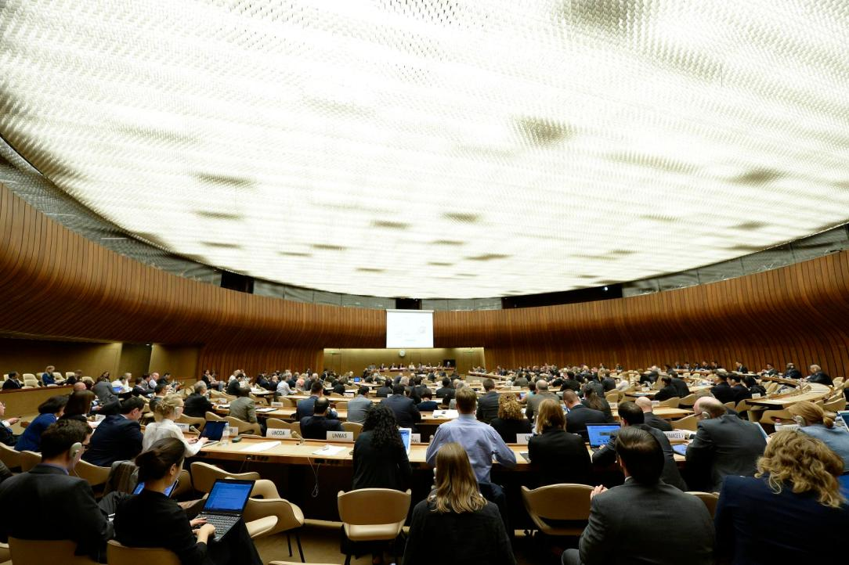

Photo: Meeting of Experts on Lethal Autonomous Weapons Systems of CCW (2015) UN Photo / Jean-Marc Ferré

Weapons programmed to hunt and kill people? That’s the urgent, hi-tech question governments representing most of humanity just debated for 10 days in Geneva. A majority argued strongly to negotiate a ban on such weapons—a step already supported by nearly 70 states and more than 180 civil society organizations, including Pax Christi International.
No, said a small minority of governments with big militaries already working towards autonomous weapons, the existing laws of war apply to killer robots. 10 more days of meetings next year will do.
So, faced with growing prospects of robots that select and strike targets on their own, members of a United Nations treaty set up to curb especially dangerous weapons could only agree to keep talking. It is the ninth year of deadlock on the issue at the Convention on Certain Conventional Weapons (CCW), after 2013 referral from the UN Human Rights Council.
“It’s now clear that a minority of states including the US and Russia, already investing heavily in the development of autonomous weapons, are committed to…block progress towards an international legal response to autonomy in weapons systems,” the Campaign to Stop Killer Robots concluded. Pax Christi International is a member of the campaign.
“States should feel confident that outside this room, the majority of public opinion, experts in artificial intelligence and technology, researchers and academics, faith leaders from around the world and the UN Secretary General, will all be with us” in negotiating a new treaty, Ousmann Noor of the Stop Killer Robots campaign told the closing session.
Throughout the 10 days of debate, states and civil society organizations from Latin America, Europe, Africa, Asia and the Middle East pushed for urgent action on legally binding prohibitions and obligations regarding robotic weapons. A carefully crafted compromise to build on past work was developed at an experts meeting during the first week of the CCW conference, 6-17 December 2021. However, the misuse of consensus at the United Nations enables failure in such circumstances. Paragraph by paragraph and even word by word, Russia took the lead in rejecting or watering down the compromise. The delegations of the United States, Israel, United Kingdom, Australia and South Korea offered varying degrees of support plus much silence.
“It is important to remind ourselves that on the other side of decisions in Geneva are human beings. The time to act on killer robots is now,” Merel Selleslach, a campaigner from Pax Christi Flanders, said of the meeting. “A clear majority of states is calling for a legally binding framework on lethal autonomous weapons, making me hopeful to see treaty negotiations starting up next year.” It is a way forward on the minds of many there.

Links
Pax Christi International
http://www.paxchristi.net/

Pax Christi U.S.A.
http://www.paxchristiusa.org

Pax Christi Texas
http://www.paxchristitexas.org

Pax Christi Dallas
http://www.Paxchristidallastx.org

Pax Christi San Antonio
http://www.paxchristisa.org

Marianist Social Justice Collaborative

www.msjc.net

Sisters of Charity of the Incarnate Word, International JPIC Committee
http://saccvi.blogspot.com/

San Antonio Peace Center
http://www.sanantoniopeace.center

Texas Catholic Campaign to End the Death Penalty
www.txccedp.org

Dialogue Institute of San Antonio
www.thedialoginstitute.org/san-antonio/

Climate Change
www.creation-care.com

Catholic Books Review
http:/catholicbooksreview.org

Beloved Community Project
http://belovedcommunityproject.org/

